Nicholas A. Ulrich
January 28, 2014
PRAD 555
Executive Summary
Lululemon Athletica Media Audit (Yoga Pants Crisis)
The subject I researched using CisionPoint was the Lululemon Athletica crisis involving the sheerness of their yoga pants. I researched 103 news outlets through CisionPoint with 83 of them being online/print, 12 of them story broadcasts, and 8 of them being radio. The main headlines found on the subject involved the revelation of their yoga pants being too sheer or see-through which made up about 48% of the headlines, the stepping down of their CEO Chip Wilson made up roughly 28%, and the falling stock of Lululemon Athletica was at 24%.
Knowing that the company opened its’ doors in 1998 in Vancouver it was no surprise that 25% of the news outlets were from Canada including Canadian Business, Vancouver Sun online, Edmonton Express, and Canada.com. Even Great Britain got in on the news with about a 8% share of the outlets mainly with Bloomberg which is not surprising based on the fact that Lululemon has opened its’ doors to countries all over the world. Yet the biggest media outlets came from the United States with a good 65% with big names like the Huffington Post, MSNBC, NYMag.com, and the New York Times. The remaining 3% came out in outlets from various other countries around the world.
For social media, I saw close to 60 tweets and Facebook posts in reference to either the recall, the sheerness of the yoga pants, or the stepping down of CEO Chip Wilson
The Breakdown:
- 150 stories have run Lululemon Athleticas yoga pants dilemma in the last 3 months and over 56 blogs have been written on the matter as well
- The Tone:
    - 62% were somewhat negative to very negative
    - 18% were neutral
    - 20% were somewhat positive
- Quotes:
  - “Shareholders accused Lululemon of hiding the defects, using deep discounting to boost market share, and concealing plans to replace Day,” states MSNBC news
  - “An online petition is calling out Lululemon, asking its founder Chip Wilson to stop blaming his company's quality issues on women's bodies,” explains the Huffington Post
  - “If Lululemon pants wear out quickly with normal use, please acknowledge that there is a problem with your pants without blaming women. And to show your sincerity, make clothing for a wider range of body sizes than those found in Lululemon shops. Stop acting like only the thinnest of women have value,” from the Vancouver Sun

Social Media Outline: at every chance when a consumer wrote to Lululemon they responded quickly and professionally as you can see below:
- It recently posted this advertisement on its Facebook page about applying to be their new CEO
- 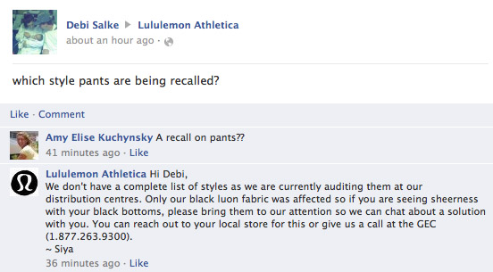
- 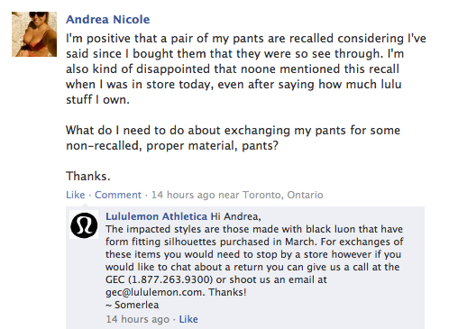
- The CEO posted an apology to YouTube. www.youtube.com/watch?v=u4jIBlTIkSk
  - No response from Lululemon on YouTube about horrible apology
- @MilaMimica1 We’re deeply sorry, the display is being taken down. We celebrate the thighs rub together- ours do too
- @trish_good If you're experiencing sheerness with your gear, bring them into a store or call 1.877.263.9300 opt 2 and we can help.‬
Although they responded quickly and professionally to people who outreached to them, it seems as though they lacked in outreaching to the public on social media sites.
Coverage versus Generated
- Coverage: We keenly listen to your feedback and it is paramount to us that you know we're listening. We are 100% committed to doing the right thing for our guests and living our standards. It is with these intentions in mind that we've pulled the affected product from our floors and website. Lululemon blog
  - Generated: Quality issues could undermine Lulu's brand, analysts say
- Coverage: We are committed to making things right so if you purchased product from our store or on our website and you think it is too sheer, we welcome you to return it for a full refund or exchange. Lululemon Blog
  - Generated: This isn’t Lululemon’s first product glitch. In 2007 a New York Times investigation revealed that the company’s Vitasea line of seaweed fabric—which it claimed released “marine amino acids, minerals, and vitamins into the skin”—contained no seaweed at all. Bloomberg Business Week
- Coverage: The athletic label has just released an ad for its Full-On Luon pants, a style launched this summer which claims to have 'major support and coverage' - unlike the pants that were pulled from shelves in March when they were found to have an unacceptable 'level of sheerness'. Lululemon media release
  - Generated: The founder of athletic label Lululemon pointed the finger at 'some women's bodies' as part of the reason why a line of yoga pants were recalled earlier this year for being too sheer. dailymail.co.uk
As you can see each time Lululemon focused on fixing and making things better but in the actual media that most people are viewing it is being shown that the problem is only mounting, things are far from being fixed.
Media Sources:
- Brian Sozzi
  - 100% negative
    - Sozzi said he believes that new, better-quality products from Nike Inc (NKE.N) and Under Armour Inc (UA.N) might be cutting into Lululemon's sales.
- John Zolidis
  - 100% negative
    - We are closer to the beginning of problems for Lululemon than their resolution,” John Zolidis
- Faye Landes
  - 100% negative
    - But analysts questioned the Vancouver-based company's future amid guidance revisions that are "starting to feel like a chronic injury," as Cowen and Co. analyst Faye Landes put it.
- Christian Buss
  - 100% negative
    - This company has jeopardized its long-term relationship with its customers over the last year, via some product quality issues, via some board communication by the founder," said Credit Suisse analyst Christian Buss.
- David Johnson
  - 100% negative
    - It turned a controversy “into a major PR fiasco,” says David E. Johnson, CEO of branding agency Strategic Vision, LLC.

