Abstract
On October 8, 2014, LEGO announced the termination of their 50 year long relationship with Shell, following a very public campaign by Greenpeace against LEGO and its partnership with Shell. This case assesses LEGO’s corporate social responsibility (CSR) initiatives, their relationship with Shell, how the actual Greenpeace campaign unfolded, along with the responses to the campaign by LEGO, Greenpeace and the Media. The analysis reveals two major trends in corporate communication: the growing influence of Non-Governmental Organizations (NGO’s) and the demand of corporate transparency. The termination of the relationship provides a superior example of this growing influence of NGO’s and as the study dives more into the communication of the campaign you will see the great need for corporate transparency at all times. Ultimately, this case is valuable to all companies looking to achieve a positive reputation in the areas of CSR as well as for students, educators of public relations. Other significant values this case study offers are useful for the field of public relations, which are managing corporate partnerships, understanding consumers’ demand for socially responsible business, growing NGOs’ presence and influence, and crisis management.

Guilty By Association?
An Analysis of LEGO’s Corporate Partnership with Shell

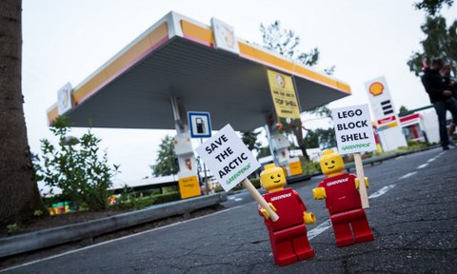

TABLE OF CONTENTS

I. CASE STUDY………………….…………………………………………………………..4-23
1. Overview……………………………………………………………………………………..4-5
2. A Brief History of Lego………………………………………………………………….......6-8
2.1 LEGO’s company background..………….………………………………………. .6-7
2.2 LEGO and corporate social responsibility…..….………………………………......7-8
2.4 LEGO and its previous challenges…………………………………………...………8
3. The turnaround of LEGO…………………………………………………………….……..9-11
3.1 Embarking on a the seven-year turnaround plan…………..……………….……...9-10
3.2 Going back to the core of the company………………………………………..…….10
3.3 Staying relevant…………………………………………………………………..10-11
4. Corporate partnership………………………………………………………………...........11-13
4.1 LEGO and Shell………...………………………………………………………...11-12
4.2 Shell and the oil industry…………………..……………………………………..12-13
5. Greenpeace Campaign………..……………………………………………………………14-17
5.1 Growing influence of NGOs…………………………………………...…….............14
5.2 Summary of Greenpeace campaign………………………………..………..……15-17
5.3 Lego’s response to the campaign and its decision…………………………………...17
6. Media and public response……………………………………………………………........17-20
6.1 Traditional and social media……………………………………………...............17-19
6.2 Greenpeace response to the campaign.…………………………………………...19-20
7. Financial and reputational impact………………………………………………………….20-21
8. LEGO’s long-term challenge……………………………………………………………....22-23

II. APPENDICES…………………………………………………………………………….…24-25
III. REFERENCES……………………………………………………………………….…26-29

- The Case Study
1. Overview
When you see the Arctic on TV, its frozen seas and vast expanses of ice and snow look like they belong on another planet. However, the damage climate change is causing to the region could have catastrophic consequences much closer to home. Saving the Arctic has been a very serious subject matter to Non-Governmental Organizations (NGOs) such as Greenpeace and WWF, specifically regarding oil and gas companies drilling in this area. Leading the charge in plans to drill in the Arctic is Shell and Greenpeace has taken the lead to stand in their way.
Since 2012, Greenpeace has taken action with their “Save the Arctic” campaign in an effort to save the Arctic from oil companies’ plans to drill in the area. An extension of this campaign against Shell was launched on July 1, 2014. The focus of this umbrella campaign was to get The LEGO Group, a very strong and reputable global brand, to end their partnership with Shell. So to look at the big picture you have to recognize the relationship of LEGO and Shell while also incorporating Greenpeace. Then you will quickly see issues and problems mount up. The Greenpeace campaign pinpoints LEGO’s dilemmas, primarily the problems with communication and CSR. The moral dilemma at its core is having to choose to end or continue a partnership with a company you’ve partnered with for over five decades, but whom also has an abysmal presence with the public for its plan to drill in the Arctic and many other issues. The communication problem comes down to being transparent with the public.
For nearly 100 years, LEGO has built itself into an iconic brand. The foundation of their legacy lies in its mission to “inspire and develop the builders of tomorrow.” Seeing that the future is colossal in LEGO’s mission also brings a dilemma to the table considering the negative impact that drilling in the Arctic can have on earth’s long-term future - an earth the future generation will be inheriting. Today, more than ever, companies have to keep a strong moral reputation because consumers look to their brands to set an example or take the chance of losing those consumers. In not knowing what negative effects come from a continued partnership with Shell, LEGO dodged a potential crumbling of their brand.
As for the campaign, although Greenpeace did not get the initial backing that it wanted nor the attention from LEGO, they trudged on. Their efforts proved to be worthwhile as the campaign quickly picked up speed through social media and a strong backing from the media. The strong support is in large part thanks to the viral “Everything Is Not Awesome” video that Greenpeace created along with LEGO’s lack of transparency with the public. The video portrays LEGO people and animals in the Arctic being swallowed up by oil that is seemingly being produced by Shell. As the online community came together during this campaign, so did the outside world in performing protests and demonstrations pleading for LEGO to end the partnership. The media were even coming together with Greenpeace and creative agencies to ensure that LEGO was listening because from the beginning until the end LEGO were quiet and far from transparent.
In the end, LEGO stood by their comments about the unfair targeting throughout the campaign and standing for nothing less than what their motto states “only the best is good enough” for the future builders of tomorrow. The statement was signaling that the dispute should have been between Greenpeace and Shell. LEGO finally realized the best option was to give in and soon stated that they will not be renewing their partnership at the current contracts end. Although Lego is currently is a positive light both financially and reputational-wise, LEGO has many challenges ahead of it.

2. A Brief History of Lego
2.1 Lego’s Company Background and Corporate Philosophy
LEGO Group, a privately held leading Danish toy maker, was founded in 1932 by carpenter Ole Kirk Kristiansen. The first bricks were invented by Ole Kirk Kristiansen in 1949, followed by the stud-in-tube system in 1957 (Pickering et al. 1999, as cited in Schultz & Hernes, 2013), and the launch of the colorful plastic LEGO bricks, which symbolize the company today, in 1958. LEGO bricks became rapidly popular because they allowed children to be imaginative in building something with the bricks. In 1974, the small yellow figures joined the product line and expanded the fun by allowing children to role-play. To date, there are 4 billion LEGO figures produced (Pisani, 2006). Today, LEGO is still loved by children and the LEGO universe can also be found in video games, movies and digital contents. In 2000, LEGO was named "Toy of the Century" by Fortune magazine and the British Toy Retailers Association.
The LEGO Group had been owned by the founder Ole Kirk Kristiansen, his son Godtfred Kirk Kristiansen, and his grandson Kjeld Kirk Kristiansen. After LEGO Group experienced a detrimental financial loss which almost resulted in bankruptcy in 2003, Kjeld Kirk Kristainsen stepped down from his President and CEO roles in 2004. The current CEO Jørgen Vig Knudstorp was appointed as the first non-family CEO of the organization to rebuild the LEGO Group. Today, LEGO Group is owned by KIRKBI A/S (75 percent) and the LEGO Foundation (25 percent) (The LEGO Group Company Website, 2014). KIRBI is an investment company owned by the Kirk Kristainsen family. LEGO Foundation is a corporate foundation that shares the mission of LEGO Group. The majority of the board members are Kirk Kristainsen family. CEO Jørgen Vig Knudstorp’s turnaround effort has resulted in LEGO Group becoming the world’s largest toy maker, surpassing Mattel for the first time (Solomon, 2014).
The LEGO Group’s mission is to “inspire and develop the builders of tomorrow” (Vestberg,n.d. ) and it stands strong on this mission. LEGO’s brand values are imagination, creativity, fun, learning, caring and quality.

2.2 LEGO and Corporate Social Responsibility
“Maximization of the positive impact the company has on human beings and society” and “minimization of the impact the company has on the environment” are the key priorities for LEGO in terms of responsibility (Vestberg, n.d.). The LEGO Group’s approach to sustainable product design is called “The Planet Promise”. With “The Planet Promise”, the company is constantly seeking ways to integrate environmental and climate concerns into the innovation process within a toy industry (Vestberg, n.d.).
One of LEGO’s strategic goals is to operate off of 100 percent renewable energy by 2020 and generate zero waste. The company has even proposed eliminating the use of oil in their plastic product by 2030 (Vestberg, n.d.). LEGO has made eco-friendly changes in the past as well. For instance, LEGO’s parent company, Kirkbi A/S, invested 3 billion crowns ($534 million) in a German offshore wind farm in 2012 to help meet the company’s renewable power target (Acher, 2012). LEGO is very actively engaged in various ecological initiatives beyond its business. For instance, in 2013, LEGO Group signed a partnership with WWF emphasizing the company’s desire to intensify its work on environmental issues such as the reduction of carbon emissions (The LEGO Group, 2013).
Nothing is more important for the company than the safety of children playing with LEGO toys. The company places a high value on the quality of the materials used for product. LEGO constantly adopts the most advanced techniques to measure and manage the chemistry that goes into making LEGO products (Vestberg, n.d.). Every year LEGO releases a Responsibility Report, which provides detailed information on all “green” initiatives the company is engaged in. These reports also show that the company‘s mission “Inspire and develop the builders of tomorrow” is not only words on the company’s website. Promoting and supporting children’s right to play and develop, the LEGO Foundation announced the establishment of the International School of Billund. This school was opened in 2013, and in this school, traditional Danish education is combined with creative approach through play (The LEGO Group, 2013).
2.3 LEGO and its previous challenges
LEGO’s history has included several external challenges. For instance, in 2011 Greenpeace attacked LEGO’s supplier Asian Pulp & Paper (APP) for deforestation in Indonesia. LEGO, Disney, Mattel, and Hasbro were criticized for their affiliation. It turned out that these companies were selling toys wrapped in packaging made from rainforest trees. LEGO became the first toy manufacturer to cancel its contracts with APP (Richardg, 2013).
Also in 2011, LEGO was accused of promoting gender stereotypes in its marketing strategy. A 7-year girl sent a letter to LEGO in which she complained that all the male LEGO minifigures got to have incredible adventures while the few female figures available did nothing but shop or go to the beach. The letter went viral. Activists started a petition on Change.org.
In its response, LEGO released a toy set “Research Institute” with minifigures of a female paleontologist, an astronomer and a chemist (Miller, Gray, 2012).
3. The Turnaround of LEGO
3.1 Embarking on the Seven-Year Turnaround Plan
LEGO’s performance started slowing down in the late 1990’s and the company faced the largest financial loss in its history in 2003-2004. LEGO’s margins decreased from 15% in 1993 to negative 28% in 2004 (Zook & Allen, 2007). Some experts considered competition from abroad, the computerization of children's playtime, and falling birth rates in many developed countries as huge factors contributing to LEGO’s failures during 1998-2004. In 1998, trying to become a lifestyle brand and attract a broader audience, LEGO started to produce clothes, watches and video games.
In 2000, the management of LEGO realized that diversification was not the right way to go:
But despite many strengths and high points, the LEGO Company was impacted because we lost focus. We will refocus on our core business. That is what the LEGO brand is about – stimulating imagination, creativity and learning – and it is what children and parents expect from us. We will continue to expand within this area, applying a growth strategy with a huge potential and lower risk. The LEGO Company will reduce or abandon certain initiatives outside of its core business, such as wristwatches, publishing and other lifestyle products (The LEGO Group, 2000, p. 1).
In order to rebuild the company, LEGO embarked on a seven-year plan: create stability and generate cash, build an irreplaceable set of core products and position for future growth. In 2009, net profits increased 63% and revenues grew 22%, resulting in the expansion of LEGO’s global market share (Zook & Allen, 2007).
LEGO has successfully fixed their problems, rebuilt their company, and climbed the industry’s ladder back up to the position of the largest toy company in the world in 2014. There are two business practices that contributed to this remarkable turnaround of LEGO: going back to the core of the company, and staying relevant.
3.2 Going back to the core of the company
One of the business practices that contributed to the remarkable turnaround of LEGO is its decision to go back to the core of its business. LEGO’s turnaround plan included shedding most of its unrelated businesses, and LEGO ended up trimming a third of its product line (Max, 2013). By shedding the unrelated businesses, LEGO went back to the core of its business: Bricks. LEGO focused on renewing the original model through conducting Research and Development as well as valuing customer insights, which we will discuss in 3.3.
3.3 Staying Relevant
The third factor contributed to the successful turnaround of LEGO is its effort to remain relevant. They have stayed relevant by truly listening to its customers’ voices, renewing its brand values and culture, and joining the digital media and movie. LEGO conducted extensive R&D. LEGO began valuing more customer insights and refined the original model of bricks (Bradley, 2014). Today, LEGO produces products based on fans’ ideas (Miller, 2014).
LEGO also stayed relevant by renewing organizational values and identity. In the late 1990’s, LEGO had lost touch with its customers and had become inward looking. LEGO’s internal culture which lacked “speed, change readiness, simplicity, and innovative solutions” (Iversen, 2003) hindered LEGO from responding effectively to external demands due to its financial crisis. LEGO’s brand values: imagination, creativity, fun, learning, caring and quality, were successfully redefined. Today, these values are not only reflected externally, but also internally through various business processes that have resulted in “performance-driven” culture as well as “customer-focused” approach (Iversen, 2003).
LEGO’s venture into digital media and cinema contributed to its successful turnaround. LEGO tries to keep up with the cutting-edge-technology. While LEGO believes that humans are wired to engage in physical play even in this digital age, it embraces what digital can do (Gustafsson, 2013). In 2004, LEGO developed LEGOfactory.com, a website where children can download LEGO digital designer and build his/her own LEGO model (Pisani, 2006). Lego has also been successful in the video game sector. LEGO began selling video games in1997 and 5 million video games were sold in 2010 (Counts, 2011). The LEGO movie, which was released in February 2014, has been a game changer for LEGO. It sold $470 million at the global box office, helping LEGO gain more popularity and branch out to broader markets (Solomon, 2014). The success of the movie boosted sales of LEGO’s products resulting in it becoming the largest toy company in the world.
- Corporate Partnership
4.1 LEGO and Shell
Corporate Social Responsibility (CSR) is considered as an opportunity to build a company’s reputation and to contribute to society at the same time. According to the article “Making the most of corporate social responsibility”, finding right partners is one of the most important principles when choosing the appropriate CSR activities (Keys, Malnight, Van der Graaf, 2009).
“Relationships—particularly long-term ones that are built on a realistic understanding of the true strengths on both sides—have a greater opportunity of being successful and sustainable.” (Keys, Malnight, Van der Graaf, 2009, para. 11). But one must remember that mutually beneficial partnerships can turn into nightmares for one of the partners if the other one’s reputation is somehow damaged.
LEGO has been partners with Shell since the 1960s. This partnership continued until the 1990s, and was renewed again in 2011. In 2014, Ferrari joined LEGO and Shell in their co-promotion activity. The 2014 Collection includes six LEGO toy sets: four Ferrari car models, a Shell station with a Scientist LEGO Minifigure, and a Finish Line and Podium with a Ferrari Engineer LEGO Minifigure.
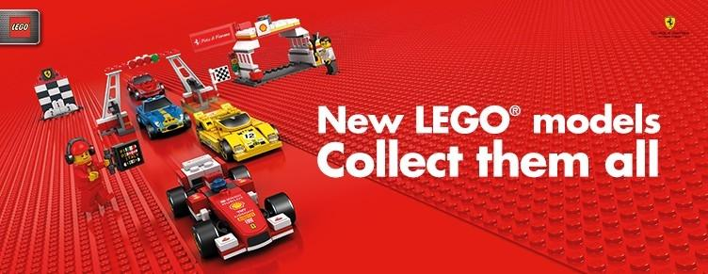

(Royal Dutch Shell, n.d.)
Shell is the exclusive distributor of this collection. Now Shell-branded toy sets are sold in 26 countries around the world. LEGO and Shell do not disclose the value of their co-promotion partnership, but according to different estimates, it is worth $103-$116 million (O’Reilly, 2014; Sullivan, 2014).
4.2 Shell and oil industry
Royal Dutch Shell, commonly known as Shell, is the biggest European oil and gas company headquartered in the Netherlands and incorporated in the United Kingdom. Royal Dutch Shell was created by the merger of Royal Dutch Petroleum and UK-based Shell Transport & Trading.
Shell’s market capitalization is $226.90 billion (Appendix 3). Shell is one of the world’s six largest publicly owned oil and gas companies, also known as supermajors and Big Oil. Other supermajors are considered to be BP, Chevron Corporation, ExxonMobil Corporation, Total SA, and ConocoPhillips Company.
Shell’s reputation was damaged after oil spills in Nigeria in 2008. The company was criticized for trying to minimize the amount of oil spilled. Investigations showed that the oil that Shell spilled in the Niger delta was at least 60 times greater than the company reported (Vidal, 2012). In August 2014, Shell revealed its plans to explore for oil in the Arctic by submitting a new offshore drilling plan to US authorities.
Greenpeace claimed that the approval process for drilling the Arctic was a formality and that Shell would be able to do whatever it wanted in the Arctic by summer 2015. As explained by Nichols (2014, para. 2), “The company is lurching forward despite the flood of reports from government agencies and environmental groups that Arctic drilling is too risky, that the Arctic is too vulnerable, and that Shell itself is too incompetent to proceed”.
Often the image of the companies depends on the general perception of the industry. Activist organizations play an important role in attracting the public’s attention to companies’ actions. Oil and gas companies are often associated with environmental issues, which makes energy one of the least reputable industries in the United States, according to the “2014 Most Reputable U.S. Companies” report (The Reputation Institute, 2014).

5. Greenpeace Campaign
5.1. Growing Influence of NGOs
For a recap, what is an NGO? NGO stands for non-governmental organization. Typically, an NGO is a group of citizens voluntarily organized either on a local, national, or international level. Backed by a common interest such as human rights or the environment, the people making up the NGO are driven and advocate for the greater society by bringing concerns and issues to governments (University of Dublin, 2006). Whether you see them as “puppets” of foreign states or the “conscience of humanity” there is no denying the growing influence that they have around the world. Pamela Aall of the United States Institute of Peace notes, “the large number of non-profit organizations in the U.S. is a reflection of American's deeply held values of individual initiative and social responsibility,” (Voice of America, 2014, para. 5).
These values can be seen in the rise of millennials; as they begin making their stake as the next influencers and leaders of society. Millennials have high expectations for social impact for not only themselves but for the companies they follow as well. Despite their high expectations for companies, they believe the majority of companies won’t actually make a change. Only 15 percent of millennials truly believe companies’ can and will make a social or environmental impact (Cahan, n.d). NGO’s are giving a louder voice to millennials and society at large. “It allows citizens to take responsibility for how their society is performing and allows citizens to talk to their government in organized ways. And in an open system, there are organized ways -- even on very difficult issues," says Aall (Voice of America, 2009, para. 6). The key point that brings the growing influence of NGOs together is that people often trust them more than their own government and when such trust is present is loudens the voice of NGOs.

5.2 Summary of the Greenpeace Campaign
As stated above, so much trust has been allotted to NGOs, giving them the ability to make great impacts on the issues that they are involved with. The Greenpeace campaign targeting LEGO to end their partnership with Shell is an excellent example of this. The catalyst for the campaign was Shell resuming plans to drill in the Arctic. Plans had been quashed at the beginning of 2014 for Shell but the company’s intentions never ceased. Greenpeace had been following Shell for years about their intentions to drill in the Arctic and in July of 2014, Greenpeace decided to act. July was the two-year anniversary of Greenpeace’s “Save the Arctic” campaign against Shell and Greenpeace marked the anniversary by igniting a direct campaign against LEGO, specifically its partnership with Shell (Flynn, 2014).
On July 1st of 2014, after hearing about Greenpeace’s intentions to target LEGO in their new campaign, LEGO CEO Knudstorp quickly responded with, “the matter was one for Shell and Greenpeace to handle,” and expressed regret at the use of the LEGO brand in the dispute Knudstorp said Lego intended to live up to its long-term contract with Shell (Tilley, 2014). Lego also posted a series of tweets to its Twitter feed paraphrasing the statement (White, 2014).
Then on July 8th, Greenpeace released an animated video on YouTube. The video utilizes LEGO’s marked with the Shell logo in an Arctic setting. The video exploits the popular “Everything is Awesome” song of the very popular 2014 LEGO movie. The song is mellowed to a somber as oil spreads and covers the Arctic along with LEGO people and animals with only a Shell LEGO flag left rising above the oil. With the LEGO and Shell partnership being heavily based on LEGO toys being branded with the Shell logo, this video was a sure-fire way to ignite the Greenpeace campaign; and the video did more than just ignite the campaign, it set the campaign ablaze. The video quickly went viral, being shared widely on Facebook and Twitter as well as gaining over six million views on YouTube. This became Greenpeace’s most viral video in it its history (Pantsios, 2014).
Soon after the video was released, a petition titled “Cut Ties With Shell” was started and quickly 155,000 signatures were gained. After not hearing anything at all from LEGO, a plan was devised to deliver the 155,000-signed petition to LEGO’s UK headquarters in Slough. The people delivering the petition were dressed in LEGO outfits but were denied access, which ignited a similar attempt at LEGO’s headquarters in Denmark with similar results. But LEGO didn’t respond or comment on the approaches at their headquarters, staying very quiet as they did throughout this entire campaign (Tilley, 2014).
After a busy July 2014 for Greenpeace, the following months of August and September were riddled with protests and demonstrations put on by the public as well as Greenpeace. Greenpeace kicked off these proceeding months with inviting a journalist to participate and report on a creative ideas session with top designers and creative agencies. This led to Greenpeace sneaking into Windsor and setting up pocket-sized banners on the models of Big Ben and the Eiffel Tower (Vaughan, 2014). In the middle of this going on, Shell announced on August 28th that they would resume plans to drill in the Arctic in the coming year of 2015. With this announcement Greenpeace vamped up the campaign, got the children involved by building animals out of LEGOs on the doorstep of the company headquarters in London and also by releasing another viral video that reached over 350,000 views (Nichols, 2014). By mid-September 2014, the petition had reached 16 percent of the viewers of the initial Greenpeace video, obtaining roughly 866,000 signatures (Lyza, 2014).
With still nothing being released from LEGO, protests reached around the world at various international landmarks and in one instance 5,000 mini figures were released to dozens of local groups to take to Lego stores and engage the public in mini protests; and thus this would be known as the “Legolution” (Polisano, 2014). By the end of September 2014, Greenpeace’s initial video had been viewed over six million times, the petition had reached over 1 million signatures (and counting), and over one million people had emailed LEGO pleading for them to end its partnership with Shell (Duff, 2014).
5.3. LEGO’s Response to Greenpeace’s Campaign
Finally, on October 3rd of 2014, LEGO CEO Knudstorp released a statement (Appendix 1) signaling that LEGO would not be renewing the partnership with Shell when the current contract expires. The proceeding days were met with rejoicing responses from Greenpeace and supporters but the campaign itself has continued with a long-term mission of stopping any chances of Shell pursuing plans to drill in the Arctic. As mentioned in the above section, the initial statement, which was also posted as various tweets on the same day in response (Appendix 2), by LEGO in early July was earmarked by the unfairness of Greenpeace’s campaign directly targeting them; believing that the issue was between Shell and Greenpeace. The statement on October 3rd followed suit and also emphasized and reinforced LEGO’s motto “only the best is good enough” (Trangbeak, 2014).
6. Media and Public Response
6.1. Media’s Response
There is no question of did the media and public have an impact on this campaign. To just say they had impact would even be an understatement. Social media and the media itself proved to be just as big as Greenpeace in getting LEGO to announce that they would not be renewing their partnership with Shell at the end of the current one. Without the multitude of video shares on the Internet, the brainstorm sessions with journalists, and the widespread buzz, the campaign may have not had much of an impact. But one aspect that is interesting to look at is the response both at the introduction of the campaign as well as at the final statement made of LEGO by traditional media as well as on social media.
At the very beginning of the Greenpeace campaign, there was not much hope for its success. Much of the social media that was surfacing at the time was essentially questioning how one could really target a company on the premise of being associated with using crude oil. This idea was based on the fact that crude oil makes it into the lives of everyone in the world at some point during a typical day. Below is an example of a Facebook post made at the beginning of the campaign.
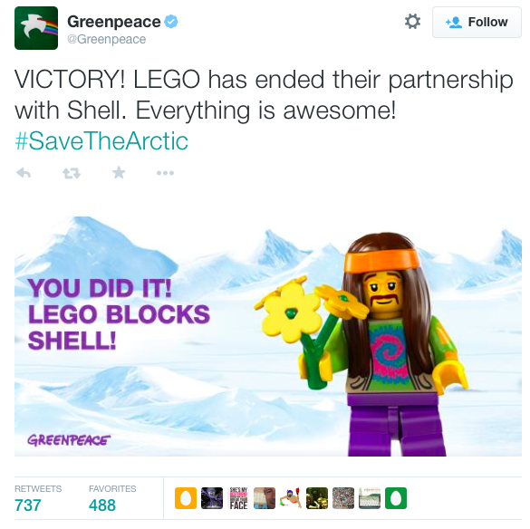
(Greenpeace, 2014)
But do not think that there were not supporters because there were. The #legoblockshell was very successful for Greenpeace. The hashtag really helped the initial push to get the video and petition spreading (Heath, 2014). Yet, as the media began writing about the “tepid corporate reaction to controversy” responses by LEGO, the media were also suggesting strongly that Greenpeace should in no way expect LEGO to even consider ending its partnership with Shell. That is exactly what Patrick Coffee from PRNewser stated in an article; “We doubt that Greenpeace’s campaign will lead LEGO to reconsider the partnership (supposedly worth at least $116 million per year to Shell) or cause Shell to strengthen its own sustainability initiatives, but we assume there will be an additional response to this video (Coffee, 2014, para. 4).
Yet as Greenpeace trudged on and the video and petition started picking up speed on the Internet, the responses began to change as well. The responses spoke of the number of views their video received, the number of signatures they acquired for the petition, and the public coming together on protests and brainstorming sessions (specifically the journalist coming and meeting with creative agencies as was mentioned above); all of these pieces brought a lot more hope for the campaign. Once people started believing in the campaign, they then started pleading with LEGO to end the partnership.
So now that Shell has opted out of renewing the partnership, what is buzzing on social media and in the media about it all? It is primarily positivity now. Many rejoiced in saying “victory” and stating, “Everything is Awesome Again”. There were still pessimists out there like Michael Skapinker of the Financial Times, who explained, “As societies, we have complicated and possibly inconvenient choices to make about our energy future. To think we can deal with them by stigmatizing the oil majors is childish – an acceptable quality in young Lego builders, but not in the rest of us.” Besides the few pessimists like Mr. Skapinker the majority of people, whether the public or media were now strongly backing Greenpeace (Skapinker, 2014, para. 3).
6.2. Greenpeace Response to the Campaign
Another response that is important to look at is the response of Greenpeace about the campaign. In summary, Greenpeace, like the rest of the world, believes that LEGO is a great company leading the way for companies with their social and environmental values. The advances they have made in recent years in reducing their environmental impact has been leaps and bounds beyond what other companies have done. But on the darker side, Greenpeace believes they are helping Shell in masking their crimes against the environment. They also suggest that by helping in this that they are not living up to the great values that people associate with LEGO and are putting aside consideration of saving the planet for the “future builders of tomorrow”.
Another statement that was thrown around by LEGO was the unfair targeting they received in believing that the campaign should have been focused solely on Shell and Greenpeace. Greenpeace responded to this by suggesting that by LEGO, by partnering with Shell, had chosen sides in the dispute. By picking sides they are put themselves in the middle of it all. So Greenpeace states, “As long as LEGO is helping Shell they'll be a legitimate target of any campaign that hopes to challenge Shell” (“How has LEGO responded”, 2014).
7. Financial and Reputation Impact
Financially, LEGO is in great shape. With just having the first half of 2014 numbers, revenue has risen 11%, to DKK 11.5 billion from DKK 10.4 billion during the same period last year. On September 4, 2014, LEGO has toppled Mattel as the biggest toy maker in the world based on sales. As for operating profit for LEGO, in their first six months profit grew to 3.63 billion DKK compared with 3.24 billion DKK last year. By not knowing how the numbers are doing in this second half of the year, it will be interesting to see the effects of this campaign and the implications of ending a partnership with Shell, which is reprtedly worth roughly $103 million dollars. The holidays and the release of the ever-so-popular LEGO movie DVD may boost LEGO’s second half numbers (Hansegard, 2014).
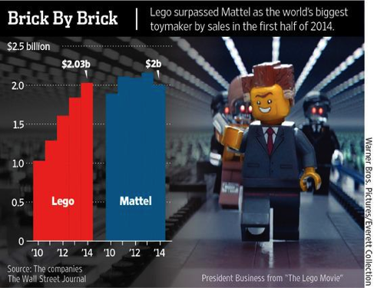
(McCullough, 2014)
As for reputation, LEGO is in the same boat as they are in financially. They are looking great but still we will need newer statistics to be released. But as it stands LEGO ranks number 9 on the Global RepTrak rankings and for the sixth year in a row LEGO was ranked number 1 in the Dutch reputation rankings. Reports suggest that they have taken a hit on their “LEGO can do no wrong” reputation during this campaign but many believe they have only helped themselves by finally ending the partnership with Shell (Trangbeak, 2014). For instance, Mark Borkowski, a brand consultant and founder of PR company Borkowski.do, said that Shell is the only partner who has benefited from the co-promotion with Lego. “Kids have a very honest and pronounced view on things such as the Earth and animals. I wondered why Lego with such a strong brand and such dominance would get into bed with Shell,” he said (Vaughan, 2014).
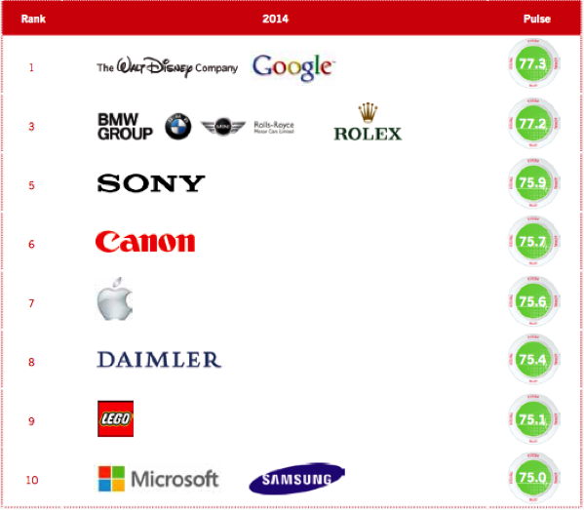
(Trangbeak, 2014).
- Lego’s Long-Term Challenges
Consumers’ expectation for corporations has changed over the years. We live in a society in which consumers question corporations’ strategies, and products, and value transparency and social responsibility as the required key elements for successful and reputable corporations. As seen in this case, the influence of NGOs and activists groups is growing. Digital media also enables people’s voices to be heard. Considering this climate we live in, LEGO faces long term challenges.
As the public’s demand for transparency grows, the expected quantity and quality of corporate communication also increases. LEGO will continue to face the challenge of being transparent about its business practices including its corporate partnerships and CSR. Not only LEGO will be expected to communicate with transparency, it will also be expected to communicate more and better. Communicating more proactively about its mission and values as well as its CSR efforts is also a challenge LEGO faces in order to maintain and improve its wholesome reputation.
LEGO sees minimizing the impact on the environment and maximizing the impact on society as its responsibility. To date, LEGO bricks still contain polymers which come from oil. LEGO acknowledges polymers as limited resources and is seeking alternatives (Vanables, 2013). The second long term challenge is for LEGO to fulfill its responsibility and continue to pursue more sustainable ways of producing its bricks.
Companies whose target customers are children can become an easy target for NGOs and activist groups. LEGO will likely continue to be scrutinized for its business decisions. As LEGO believes in having dialogues with all stakeholders, it is LEGO’s long term challenge to start a dialogue with NGOs and activist groups and build relationships that may be beneficial in avoiding future controversy.

II. Appendix
1.
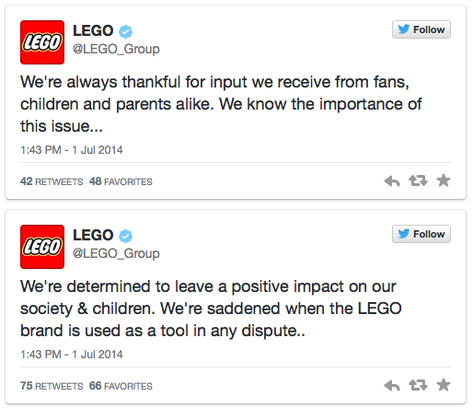
Source: PRNewswer, http://www.mediabistro.com/prnewser/lego-issues-tepid-response-to-greenpeace-video-mockery_b95390, as of November 21, 2014.
2.
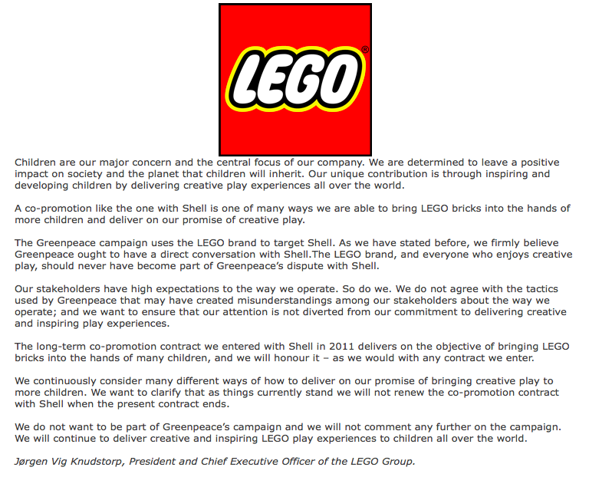
Source: The LEGO Group, http://aboutus.lego.com/en-us/news-room/2014/july/lego-group-comment-on-greenpeace-campaign, as of November 21, 2014.

3.
Source: Yahoo Finance, http://finance.yahoo.com/q?s=RDS-A, as of November, 21, 2014.

III. REFERENCES

Archer, J. (2012). Lego owners splash $500 million on green power. Reuters. Retrieved from
http://www.reuters.com/article/2012/02/23/us-dongenergy-lego-idUSTRE81M0MO20120223

Bradley, R. (2014). How LEGO got hot…again. Fortune, 31. Retrieved from
http://fortune.com/2014/02/27/how-lego-got-hot-again/

Cahan, S. (n.d). Perceptions, millenials and CSR: how to engage the new leaders of tomorrow. Cone Communications. Retrieved from
http://www.conecomm.com/csr-and-millennials

Coffee, P. (2014). LEGO issues tepid response to Shell Controversy: Greenpeace issues mock psa. PRNewser. Retrieved from
http://www.mediabistro.com/prnewser/lego-issues-tepid-response-to-greenpeace-video-mockery_b95390

Couts, A. (2011). Lego Systems’ sales surpassed $1 billion mark in 2010. Digital Trends.
Retrieved from
http://www.digitaltrends.com/gaming/lego-systems-sales-surpassed-1-billion-mark-in-2010/

Duff, I. (2014). How LEGO got awesome to #SaveTheArctic. Greenpeace. Retrieved from http://www.greenpeace.org/international/en/news/Blogs/makingwaves/save-the-arctic-lego-dumps-shell/blog/50917/

Flynn, K. (2014). Everything is not awesome with LEGO and Shell, says Greenpeace. Forbes. Retrieved from http://www.forbes.com/sites/kerryflynn/2014/07/08/everything-is-not-awesome-with-lego-and-shell-says-greenpeace/

Gustafsson, K. (2013). Rebuilding Lego for today’s kids. BusinessWeek. Retrieved from http://www.businessweek.com/articles/2013-11-07/lego-launches-toys-more-complex-than blocks-fit-for-digital-age

Hansegard, J. (2014). Oh, snap! Lego's sales surpass mattel. The Wall Street Journal. Retrieved from http://online.wsj.com/articles/lego-becomes-worlds-largest-toy-maker-on-movie-success-1409820074

Heath, S. (2014). #legoblockshell:Greenpeace critical of Lego and Shell partnership. Storify. Retrieved from
https://storify.com/shancomm11007/legoblockshell-greenpeace-critical-of-lego-and-sh

Iversen, C. (2003). Building brand values at LEGO Company. Strategic HR Review, 2-6, 8-9.

Keys, T., Malnight, T., Van der Graaf, K. (2009). Making the most of corporate social responsibility. McKinsey&Company. Retrieved from http://www.mckinsey.com/insights/corporate_social_responsibility/making_the_most_of_corporate_social_responsibility

Lyza, J. (2014). What you should know about Greenpeace's Lego campaign. Greenbiz, Retrieved from http://www.greenbiz.com/blog/2014/09/15/pushing-concerned-parent-greenpeace-and-lego

Max.S. (2013). What can your company learn from LEGO? Entrepreneur, Retrieved from
http://www.entrepreneur.com/article/227746

McCullough, A. (2014). Facebook, Retrieved from https://www.facebook.com/video.php?v=10152341707363300

Miller, K. (2014). How the Lego Company found success in the digital age — by going back to
basics. PRI, Retrieved from
http://www.pri.org/stories/2014-07-27/how-lego-company-found-success-digital-age-going-back-basics

Miller, F., Gray, E. (2012). LEGO Friends Petition: Parents, Women And Girls Ask Toy Companies To Stop Gender-Based Marketing. The Huffington Post, Retrieved from http://www.huffingtonpost.com/2012/01/15/lego-friends-girls-gender-toy-marketing_n_1206293.html

Morten Vestberg. (n.d.). The LEGO Group. Our approach, Retrieved from http://aboutus.lego.com/en-us/sustainability/our-approach

Morten Vestberg. (n.d.). The LEGO Group. Product Safety, Retrieved from http://aboutus.lego.com/en-us/sustainability/product-safety

Morten Vestberg. (n.d.). The LEGO Group. Environment, Retrieved from http://aboutus.lego.com/en-us/sustainability/environment

M.S. (2014). Childish arguments. The Economist, Retrieved from http://www.economist.com/blogs/democracyinamerica/2014/10/greenpeace-lego-and-shell

N.A. (2014). How has LEGO responded. Greenpeace, Retrieved from http://www.greenpeace.org.uk/blog/climate/how-have-lego-responded-our-campaign-get-them-break-shell-20140728

Nichols, T. (2014). Breaking: Shell announces 2015 arctic drilling plans. Greenpeace, Retrieved from http://greenpeaceblogs.org/2014/08/28/breaking-shell-announces-2015-arctic-drilling-plans/

O’Reilly, L. (2014). Here’s The Chilling Greenpeace Video That Ended Lego’s $116 Million Deal With Shell. The Business Insider, Retrieved from
http://www.businessinsider.com/lego-ends-shell-deal-after-greenpeace-viral-video-2014- 10

Pantsios, A. (2014). Victory for Greenpeace campaign as LEGO dumps Shell Oil. EcoWatch, Retrieved from
http://ecowatch.com/2014/10/09/greenpeace-lego-dumps-shell/

Pisani, J. (2006). The making of a LEGO. BusinessWeek Online, Retrieved from
http://www.businessweek.com/stories/2006-11-29/the-making-of-a-legobusinessweek-business news-stock-market-and-financial-advice

Polisano, E. (2014). Greenpeace: how our campaign ended the Lego-Shell partnership. The Guardian. Retrieved from
http://www.theguardian.com/voluntary-sector-network/2014/oct/10/greenpeace-lego-shell-climate-change-arctic-oil

Richard, G. (2013). Timeline: how you persuaded Asia Pulp and Paper to stop cutting down Indonesia's rainforests. Greenpeace’s blog, Retrieved from
http://www.greenpeace.org.uk/blog/forests/timeline-how-you-persuaded-asia-pulp-and-paper-stop-cutting-down-indonesias-rainforests-20130205

Royal Dutch Shell. (Company). (N.d.). The new Shell V-Power Lego Collection [picture on the website]. Retrieved from
http://www.shell.com/global/products-services/on-the-road/fuels/ferrari-model-lego-collection.html#iframe-Lw==

Schultz, M & Hernes, T. (2013). A Temporal perspective on organizational identity. Organization Science. 24(1), 1-21.

Solomon, B. (2014). Everything is awesome: Lego leaps Barbie for world's largest toy maker. Forbes. Retrieved from
http://www.forbes.com/sites/briansolomon/2014/09/04/everything-isawesomelego-leapsbarbie-for-worlds-largest-toy-maker/

Sullivan, T. (2014). Greenpeace Successfully Pressures Lego To Drop Shell Oil Partnership. The Business Insider. Retrieved from
http://www.businessinsider.com/afp-lego-to-drop-shell-partnership-bowing-to-greenpeace-pressure-2014-10

The LEGO Foundation. (n.d). Our Journey. Retrieved from
http://www.legofoundation.com/en-us/who-we-are/our-bold-journey/

The LEGO Group. (2000). Annual report 2000. Retrieved from
http://aboutus.lego.com/en-us/lego-group/annual-report

The LEGO Group. (2001). Annual report 2001. Retrieved from
http://aboutus.lego.com/en-us/lego-group/annual-report

The LEGO Group. (2013). Responsibility report 2013. Retrieved from
http://aboutus.lego.com/en-us/lego-group/annual-report

The LEGO Group. (n.d). Ownership. Retrieved from
http://aboutus.lego.com/en-us/lego-group/ownership

Trangbeak, R. (2014). The LEGO Group’s reputation retains its top position globally. The LEGO Group. Retrieved from
http://aboutus.lego.com/en-us/news-room/2014/april/reptrak100

Trangbeak, R. (2014). Comment on Greenpeace campaign using the LEGO® brand. The LEGO Group, Retrieved from
https://docs.google.com/document/d/1FXWJXnnUhGr6qXEJFcD2kcEN4XOYz-qoeHGssSukg1U/edit

The Reputation Institute. (2014). 2014 Most Reputable U.S. Companies. Retrieved from http://www.reputationinstitute.com/thought-leadership/complimentary-reports-2014

Tilley, J. (2014). How is Lego handling Greenpeace's pressure over Shell partnership. PRWeek. Retrieved from
http://www.prweek.com/article/1305282/lego-handling-greenpeaces-pressure-shell-partnership

Vanables, M. (2013). How Lego makes safe, quality, diverse and irresistible toys everyone
wants: part two. Forbes. Retrieved from
http://www.forbes.com/sites/michaelvenables/2013/04/20/how-lego-makes-the-safe-quality-diverse-and-irresistible-toys-we-all-want-part-two/

Vaughan, A. (2014). Lego ends Shell partnership following Greenpeace campaign. The Guardian. Retrieved from
http://www.theguardian.com/environment/2014/oct/09/lego-ends-shell-partnership-following-greenpeace-campaign

Vidal, J. (2012). Shell Nigeria oil spill '60 times bigger than it claimed’. The Guardian. Retrieved from
http://www.theguardian.com/environment/2012/apr/23/shell-nigeria-oil-spill-bigger

Voice of America. (2009). NGOs influence change around the world. VOAnews. Retrieved from http://www.voanews.com/content/a-13-2007-06-07-voa3-66555952/554776.html

White, M. (2014). This is why people are so upset at Lego. Time. Retrieved from http://time.com/2976549/this-is-why-people-are-so-upset-at-lego/

Zook, C. & Allen, J. (2012). Repeatability: Build Enduring Businesses for a World of Constant
Change. Harvard Business Review Press: Boston. MA: Harvard Business Publishing.

